Backend of Coding servers

Here, 2 is for running the loop 2 times for the two test cases 3 and 5. And each case is run by the online compiler. Our program must satisfy the test cases to pass the question. Also, you also never write the int main() part as its already written but hidden, you just need to code the function for it mostly.

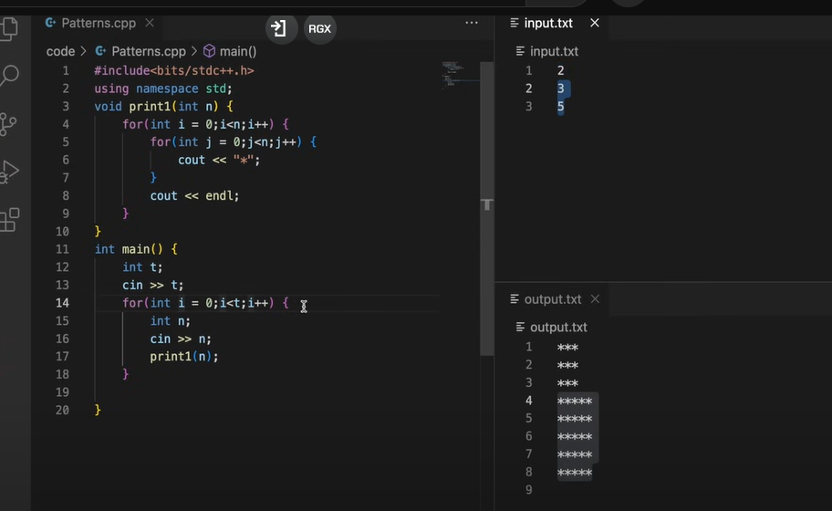

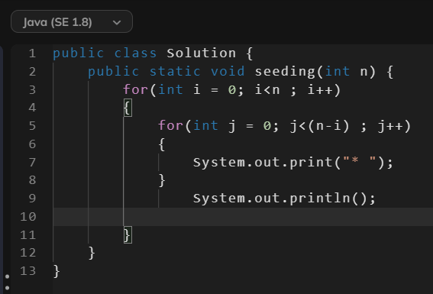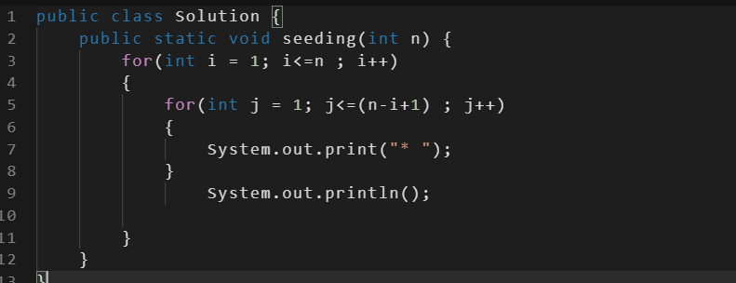Pattern5

Tip: New trick to avoid 0 indexing is just to add 1.